TABLE NIBBLES
Gordal Olives, EVOO & Rock Salt | 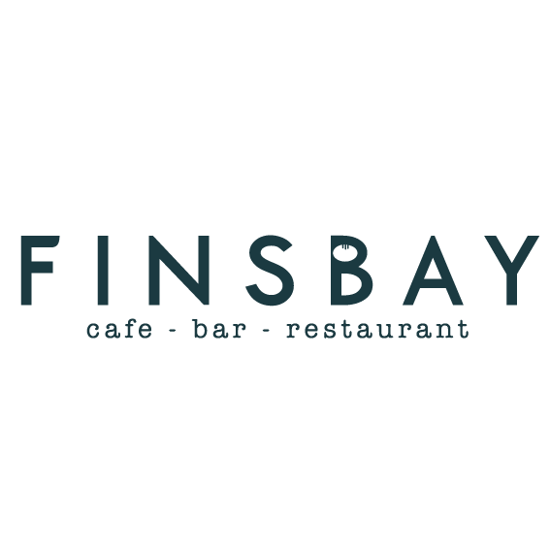  4
Salt & Chilli Corn | 3
Hummus, flatbread, whipped feta & EVOO | 4
Toasted Sourdough, Sun Dried Tomato tapenade & EVOO | 4
STARTERS
Cullen Skink  with sourdough & dairy butter | 6
Black pudding & Potato croquettes  with wholegrain mayo | 5.95
Warm summer salad (ve)  with poached pear & roast beets | 5.95
Pan Fried King scallops,  caramelised apple & chorizo | 9.50
Crispy Tempura  with cucumber & sweet chilli relish  Choice from  Chicken  King Prawn  Asian Cauliflower | 6.45  6.95  5.95
Isle of Shetland Mussels  in a Thai laksa sauce | 7.95

SIDES
Skinny Fries | 3.50
Crispy garlic and herb tator tots with aioli | 4
Feta & Olive Salad | 5
Sautéed kale, sesame & pomegranate | 4.50
Thai crackers & sweet chilli sauce | 3.50
Loaded Skinny Fries  Choose From:  Hollandaise & Parmesan  Korean Pulled Pork & Apple Slaw  Buffalo Mac & Blue Cheese | 5

DESSERTS
Cake of the Day and Ice Cream | 4.95
Sticky Toffee Pudding, served with butterscotch sauce and vanilla ice cream | 5.95
Chocolate & orange mousse, Chantilly cream & shortbread | 5.95
Baked cheesecake, fresh cream & summer berry coulis | 5.95
Selection of Ice Cream | 3.50
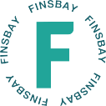

info@finsbay.com 0141 956 601

MAINS
Slow Cooked Lamb Shoulder  new potato, curly kale & pomegranate dressing | 17.95
Seafood Goan Risotto  haddock, king prawn & mussels | 16.95
Butternut Squash & Crispy Sage Gnocchi  pomegranate, EVOO & rocket | 12.95
Beef Panang  greens, Thai basil & sticky rice | 15.95
Warm Goats cheese Mediterranean Enchilada  with a Greek salad | 11.95
Finsbay Fish & Chips  beer battered haddock served with hand cut chips, side salad & tartare sauce | 13.95
Chorizo & Scallops Salad  with carnalised apple & vinaigrette | 17.95
FlatIron Steak  tater tots, broccoli tender stem & bearnaise sauce | 17.95
Buttermilk Chicken Burger  smothered in hot buffalo sauce with blue cheese dip, served with fries | 13.95
Isle of Shetland Mussels  in a Thai laksa sauce | 14.95
Veggie Burger  spicy 5 bean burger, served with fries and chipotle mayo | 12.95
Finsbay Mac & Cheese  served with fries | 12.95
£1 extra per topping
bacon, chicken, chorizo. Haggis, black pudding, tomato

